Image Processing Project
Stroke Classification In Table Tennis

Table of Contents:
I: Introduction to the project
1: Video Frame Extractor (Project.py)
  - Purpose and Overview
  - Directory Structure Created
  - Key Components
  - Processing Statistics
2: Model Building (build_model.py)
2.1 Purpose and Overview
2.2 Dataset Structure
2.3 Key Components
2.4 Training Pipeline
2.5 Evaluation Metrics
2.6 Saved Artifacts
3: Testing And Interactive Learning (test_model_standalone.py)
3.1 Purpose and Overview
3.2 Key Features
3.3 Directory Structure
3.4 Core Components
3.5 Learning Algorithm
3.6 Interactive Interface
4: Workflow Summary
4.1 Complete Pipeline
4.2 Step By Step Process
4.3 Technical Specifications

I: Introduction to the project:
This project implements an intelligent table tennis stroke classification system using computer vision and deep learning techniques. The system automatically analyzes table tennis videos, extracts key frames, classifies strokes into three categories (forehand, backhand, push), and continuously improves through interactive learning.
Objectives
- Develop automated frame extraction from table tennis videos.
- Implement a CNN model for stroke classification.
- Achieve high accuracy on three stroke types.
- Create interactive learning system for continuous improvement.
- Provide user-friendly interface for testing and correction.

Scope
Included:
- Three stroke types: Forehand, Backhand, Push.
- Video processing for frame extraction.
- CNN-based classification model.
- Interactive learning with persistent memory.
- Visual feedback and results display.
Image Processing Techniques Used:
Colour Jitter: Simulate different lightning conditions.
Normalization: Stabilize training, Faster Convergence.

1: Video Frame Extractor (Code 1):
1.1 Purpose and Overview
This module extracts frames from table tennis video recordings to create a dataset for training the stroke classification model. It processes multiple stroke categories and organizes the extracted frames into a structured directory format.
1.2 Directory Structure Created
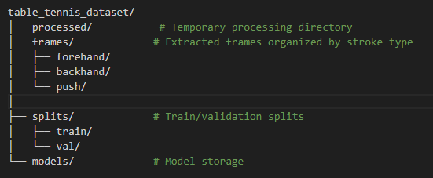

1.3 Key Components
1.3.1 Main Class: VideoProcessor
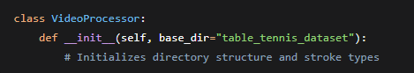
Parameters:
- base_dir: Root directory for the dataset (default: "table_tennis_dataset").
- stroke_types: List of stroke categories to process.
- ['forehand', 'backhand', 'push']
1.3.2 Core Methods
1. extract_frames_simple()
- Purpose: Extracts frames from video files at specified intervals
- Parameters:
  - video_path: Path to input video.
  - output_dir: Directory to save extracted frames.
  - frames_per_second: Frame extraction rate (default: 3 fps).
- Process:
  - Opens video file using OpenCV.
  - Calculates frame interval based on video FPS.
  - Extracts frames at regular intervals.
  - Resizes frames to reduce storage (if width > 1280).
  - Saves frames as JPEG images with standardized naming.
2. process_all_videos()
- Purpose: Processes all videos in each stroke folder
- Process Flow:
  - Iterates through each stroke category.
  - Locates video files in table_tennis_dataset/<stroke_type>/.
  - Extracts frames from each video.
  - Updates dataset statistics.
- Output: Returns dictionary with processing statistics.
3. create_train_val_split()
- Purpose: Creates training (80%) and validation (20%) splits
- Process:
  - Shuffles extracted frames.
  - Splits into train/validation sets.
  - Copies frames to respective directories.
- Ratio: 80% training, 20% validation
1.4 Processing Statistics
The module generates two files:
- dataset_statistics.json: JSON format with per-stroke counts.
- dataset_statistics.csv: CSV format for easy analysis.
- data_splits.json: Details of train/validation distribution.

2. MODEL BUILDING (Code 2)
2.1 Purpose and Overview
This module implements a Convolutional Neural Network (CNN) for classifying table tennis strokes from extracted frames. It handles dataset loading, model training, validation, and evaluation.
2.2 Dataset Structure
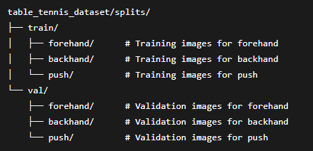

2.3 Key Components
2.3.1 Dataset Class: TableTennisDataset
Features:
- Loads images from organized directories
- Applies transformations for data augmentation
- Handles 3 stroke classes: ['forehand', 'backhand', 'push']
- Automatic image normalization using ImageNet statistics
2.3.2 Main Class: TableTennisClassifier
Initialization Parameters:
- dataset_path: Path to dataset directory
- device: Automatic GPU detection (CUDA/CPU)
- stroke_types: 3-class classification task

2.4 Training Pipeline
2.4.1 Data Augmentation for Training
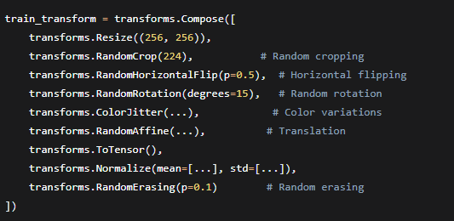
2.4.3 Training Process
- Data Loading: Creates DataLoader with 4 workers for parallel loading.
- Forward Pass: Model inference on batch.
- Loss Calculation: Cross-entropy between predictions and labels.
- Backward Pass: Gradient computation with gradient clipping.
- Optimization: Weight update using AdamW.
- Scheduler Update: Learning rate adjustment.
- Validation: Performance evaluation after each epoch
2.5 Evaluation Metrics
The model tracks multiple metrics:
- Primary: Accuracy, Loss
- Secondary: F1 Score, Precision, Recall (weighted averages)
- Per-class: Individual metrics for each stroke type

2.6 Saved Artifacts
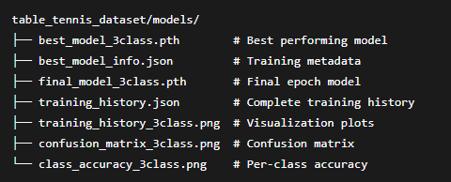

3. TESTING AND INTERACTIVE LEARNING (Code 3)
3.1 Purpose and Overview
This module provides an interactive system for testing the trained model and allowing continuous learning through user feedback. It implements "persistent learning" where the model retains corrections between sessions.
3.2 Key Features
- Interactive Testing: Test individual images with real-time predictions
- Correction Learning: Model learns from user corrections
- Persistent Memory: Saves learned corrections between sessions
- Overfitting Protection: Prevents excessive learning on same images
- Model Validation: Diagnostic tools to verify model performance
3.3 Directory Structure
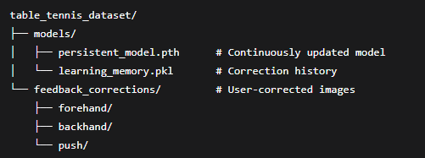
3.4 Core Components
3.4.1 Main Class: PersistentLearner
Initialization Process:
- Checks for existing persistent model
- Validates model functionality
- Loads learning memory from pickle file
- Falls back to original model if needed

3.4.2 Learning Memory Structure
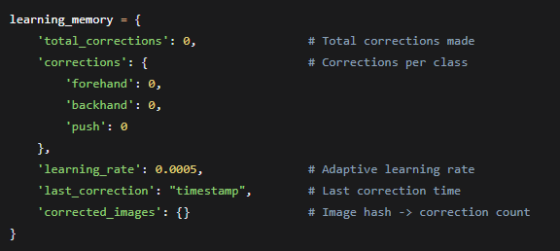
3.4.3 Key Methods
1. predict(image)
- Purpose: Makes prediction on input image
- Process:
  - Converts BGR to RGB
  - Applies preprocessing transforms
  - Runs through CNN model
  - Returns stroke type, confidence, and class probabilities
2. learn_correction(image, correct_stroke, predicted_stroke, current_probs)
- Purpose: Learns from user correction
- Process Flow:
  - Checks for overfitting (max 2 corrections per image)
  - Calculates target probability increase
  - Creates augmented batch (4 variations of input image)
  - Performs gradient descent with regularization
  - Saves updated model and memory

3. validate_model()
- Purpose: Validates model on training samples
- Process: Tests model on known training images
- Threshold: Requires >30% accuracy to pass validation
3.5 Learning Algorithm
3.5.1 Correction Process
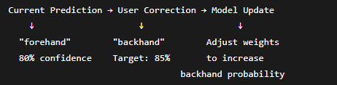
3.5.2 Adaptive Learning
- Learning Rate: Starts at 0.0005, decreases by 10% every 5 corrections
- Iterations: Reduced based on correction history
  - First correction: 15 iterations
  - Second correction: 5 iterations (overfitting protection)
- Regularization: Weight decay (0.0001) and gradient clipping (max_norm=0.5)
3.5.3 Overfitting Protection
- Image Hashing: Tracks corrections per unique image
- Limitation: Maximum 2 corrections per image
- Validation: Tests model on training samples periodically
- Early Stopping: Stops if no improvement for 4 iterations

3.6 Interactive Interface
3.6.1 Main Menu Options
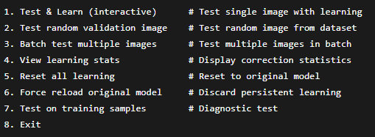
3.6.2 Interactive Testing Controls
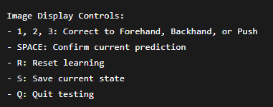

4. WORKFLOW SUMMARY
4.1 Complete Pipeline
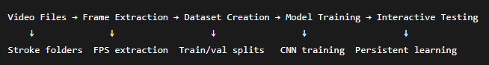
4.2 Step-by-Step Process
Step 1: Dataset Preparation
- Get High Quality Videos From Youtube or Any website
- Put the videos in there right named folders (Forehand,Backhand,Push)
- Run The Video Frame Extractor Code (Project.py)
- Generates train/validation splits
Step 2: Model Training
Run Build_Model.py
- Loads processed dataset
- Trains CNN with data augmentation
- Saves best model and training history
Step 3: Interactive Testing
Run test_model_persistent_learning.py
- Loads trained model
- Allows testing and corrections
- Continuously improves model
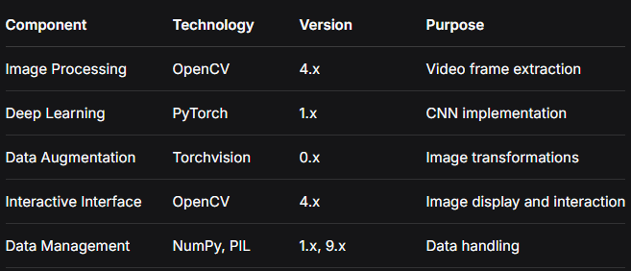
4.3 Technical Specifications

Model Accuracy:
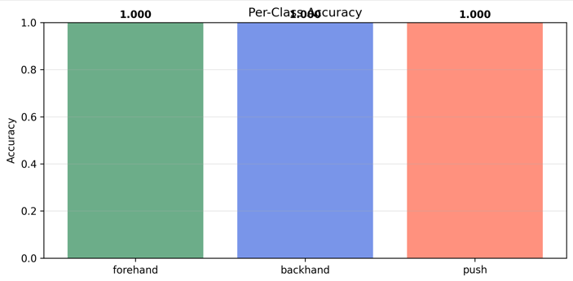

Confusion Matrix:
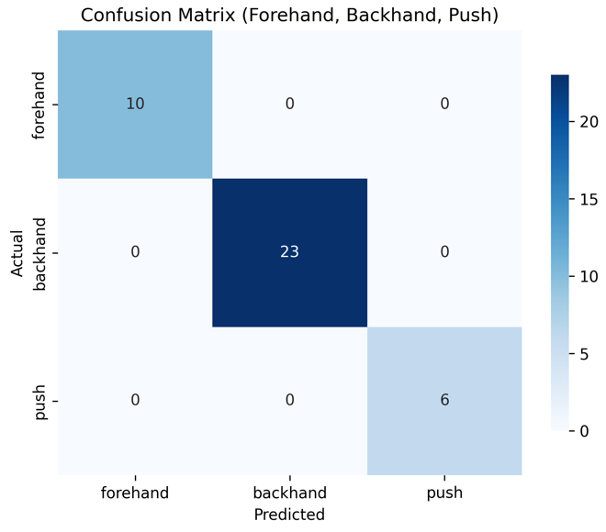

Training History
